Annual Notice to Clients - 2022

February 17, 2022
To Our Clients:
In an effort to help laboratories comply with federal laws and regulations, the Office of the Inspector General (OIG) has issued a recommendation that all CLIA certified laboratories provide annual notification to their clients regarding pertinent issues. Please review the following important information.
Incyte Diagnostics Locations:
13103 E Mansfield, Spokane Valley WA 15912 E Marietta Ave, Ste B, Spokane Valley WA
221 Wellsian Way, Richland WA 12615 E Mission Ave, Ste 108, Spokane Valley WA
9631 N Nevada St Ste 210, Spokane WA 21950 E Country Vista Dr. Ste 200, Liberty Lake WA
1307 S Grand Blvd, Spokane WA 318 E Rowan Ave, Ste 205 Spokane WA
105 W Prairie Shopping Ctr, Hayden ID 301 St Anthony Way Ste 107, Pendleton OR

The following location will be moving this year.

1280 116th Ave NE, STE 210, Bellevue WA to Riverfront Technical Park, 2811 102 St, Tukwila WA

Requisition Requirements
In addition to having an accurate patient diagnosis (narrative and/or ICD-10) indicating the medical necessity for testing, each requisition form must also include complete patient demographic information including the patient’s full legal name, date of birth (DOB), gender, and current insurance information. For gynecological testing, the requisition must also include all testing being requested for each patient including a PAP test, gonorrhea and/or chlamydia testing. When a PAP test or HPV test is ordered, the requisition must also include the source (cervical v. vaginal), LMP date and any other clinically significant information. Please note that if any required information is missing on a requisition, it may impact turnaround time while we contact the client for the missing information.
Specimen Labeling
Regulations require that each primary specimen be clearly labeled with at least 2 patient identifiers. A primary specimen container is the innermost container that holds the original specimen prior to processing and testing. This may be in the form of a specimen collection tube, syringe, swab, slide or other form of specimen storage. For prepared slides submitted to a laboratory, if the slides only contain one identifier, they must be securely submitted in a container labeled with two identifiers. If specimen containers are not appropriately marked, turnaround time could be impacted while we contact the client to confirm specimen labeling information.

Prior Authorization
Many payers are now requiring prior authorization (PA) before testing will be reimbursed. Please consult with individual payers for PA requirements prior to sample collection. Prior authorization numbers should be included on the requisition.
Medical Necessity
Per applicable CMS regulations, we require all testing requisitions/orders to contain a diagnosis and/or ICD-10 code(s) supporting the tests ordered by our clients. Medicare has issued both National and Local Coverage Determinations (NCD/LCD) that outline coverage specifics. To access NCDs please visit CMS’ website at www.cms.gov/medicare-coverage-database/overview-and-quick-search.aspx . In addition, LCDs for our area can be accessed on Noridian’s website at https://med.noridianmedicare.com/web/jeb/policies/lcd/active . In some instances, it may be necessary to obtain additional medical records from our clients to support medical necessity.
For pathology and laboratory testing a signed requisition is not required; however, all orders must be supported via signed chart notes and made available upon request.
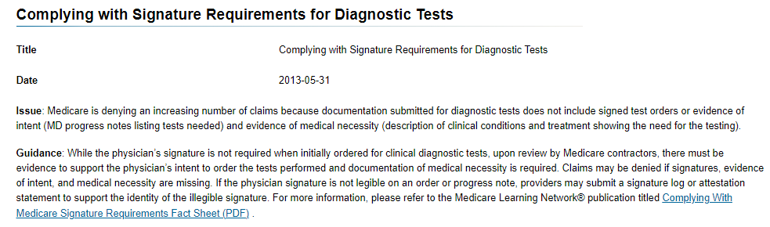
https://www.cms.gov/Outreach-and-Education/Medicare-Learning-Network-MLN/MLNProducts/Downloads/ProviderComplianceLabServices-Fact-Sheet-ICN909221.pdf#:~:text=requisition%2C%20or%20a%20medical%20record%20supporting%20the%20physician%E2%80%99s,laboratory%20services%20documentation%20includes%20the%20order%20%28including%20standing
Advanced Beneficiary Notice
Medicare requires Advanced Beneficiary Notice be given to the patient prior to the collection of a testing sample for some tests including cervical cancer screening (PAP test) and Human Papilloma Virus (HPV)screening when not performed in accordance with Medicare NCDs 210.2 and 210.2.1. English and Spanish versions are available at https://www.incytediagnostics.com/client-support/abn/ .
Please consult the following NCDs to determine whether an ABN is required for other clinical laboratory tests.
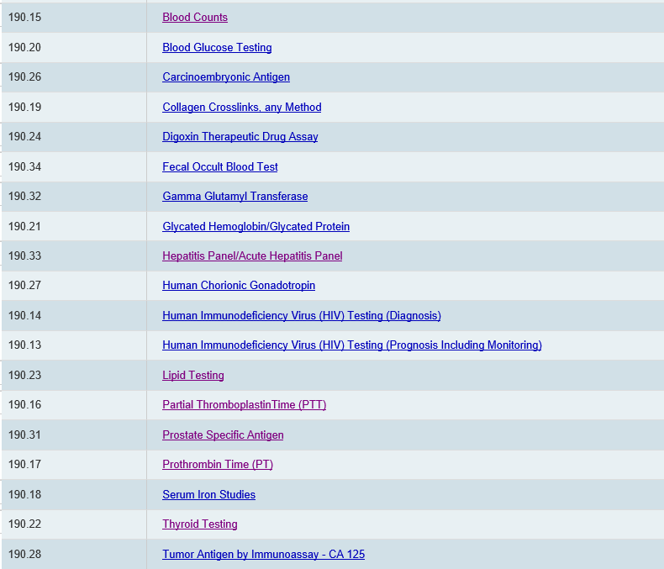
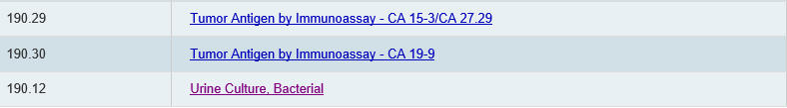

Flow Cytometry and molecular tests are also covered under LCDs which can be found at the Noridian website listed above. If testing is to be performed outside the guidelines set forth in the LCDs, a valid ABN must accompany the request to ensure reimbursement. Corresponding billing and coding articles may also be useful.

Technical Component/Professional Component Testing
Federal guidelines require that any pathologist who performs the professional component (PC) of testing be appropriately trained and credentialed for that specialty. All Incyte pathologists meet this requirement. Each of our laboratory locations is CLIA certified and participates in regular CAP or state inspections.
Billing Information
Unless Incyte has agreed ahead of time to “client-bill” for testing, we will attempt to bill directly and collect from third party insurers, health maintenance organizations, and federal and state health insurance programs (Medicare and Medicaid). Per regulation we are required to bill hospitals for the clinical lab and technical pathology services provided to Medicare inpatients and outpatients of a hospital or its provider-based clinics.
Patient Requests for Records
In 2014, Federal HIPAA regulations were changed and allow patients to call the laboratory directly to obtain their test results. We are required under Washington state law to accommodate these requests within 15 business days.
Proficiency Testing
Per CLIA regulations, Incyte Diagnostics is unable to accept client proficiency testing (PT) requests. Under most circumstance, all aspects of PT testing should be performed by the client at their facility. As a result, Incyte will not accept PT testing.
Creutzfeldt – Jakob, Prion or Mad-Cow Disease
Incyte Diagnostics will not perform any testing on specimens or patients with known or suspected Prion Disease, such as CJD or TSE (Transmissible Spongiform Encephalopathy). This includes cerebral spinal fluid (CSF), brain biopsies, spinal cord biopsies or autopsies. This includes tissue that is fresh, frozen or fixed in formalin or alcohol. In addition, any specimens of patients with or suspected of having TSE will be sent to a facility that specializes in handling these types of specimens. Incyte should be notified of possible CJD or other TSE infected patient cases before any specimen/tissue is sent to Incyte.

For additional information, please visit our website at http://incytediagnostics.com.

